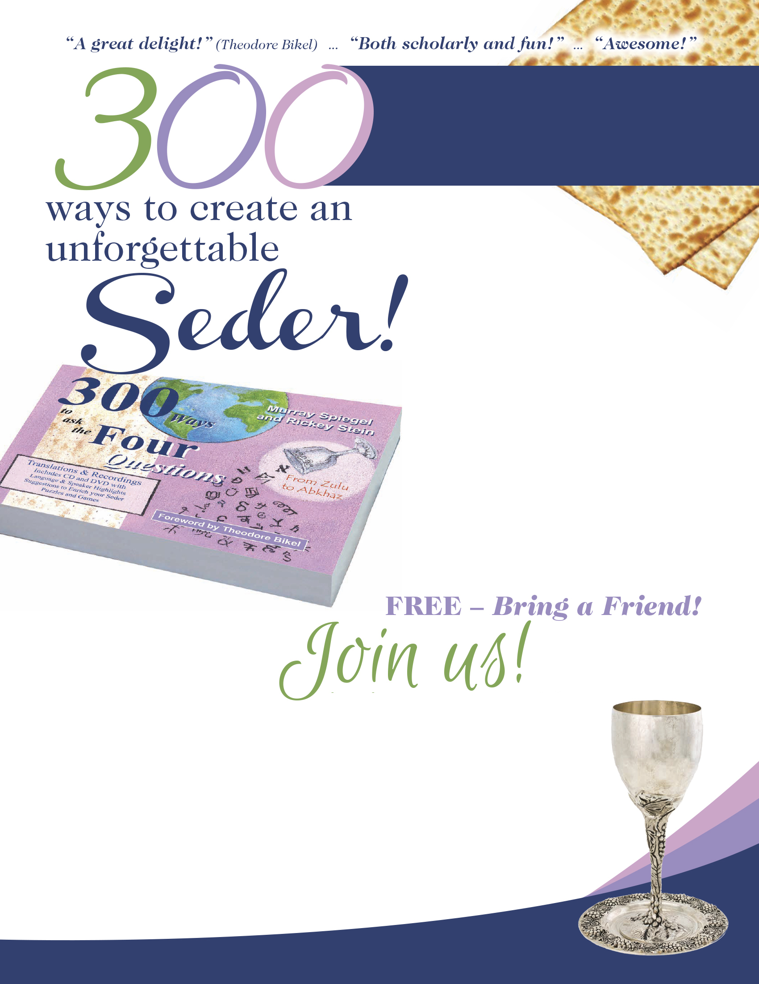

Find out how to create
an enthralling seder
for your kids!
Murray’s innovative seders were featured
on PBS! Get inspired – hear an intriguing, humorous, multimedia presentation that's created unforgettable seders around the world. Novel ideas for your seders with kids include music, interactive games, parodies and quizzes, plus unusual, historic as well as wild contemporary versions of the 4 Questions, and captivating connections to Jewish cultures
all over the globe.
Find out how Shakespeare,
Donald Duck, Klingons, Lawyers,
Phoenicians (and Jews around the world)
say the Four Questions!

About the Author:
With a passion for Judaism, Passover
and language, speech researcher
Dr. Murray Spiegel has a reputation for innovative seders, which were featured in The New York Times and filmed by PBS. Enjoy his infectious enthusiasm and learn how to make your next seder – no matter how old or young your kids are – the most fun
and interesting it’s ever been.

SPECIAL
(Your Organization Here)
PASSOVER PROGRAM

Sunday, Month Day
Time AM/PM
FOR information contact:
NAME at email@address.com
or call PHONE

(Fill in) Organization Name and Address

for a fun, participatory program
with trailblazer Dr. Spiegel
and make YOUR seder night...
“Different from all other nights!”

FREE – Bring a Friend!

