**Organization Name Special Passover Program**

*300*

Ways to Create

an Unforgettable

Seder!

Presented by

Dr. Murray Spiegel,

whose fascinating, humorous, innovative Seders have been featured on PBS and in

The New York Times.

Join us for a  
Passover Prep workshop

unlike any other!

**DAY, MON DATE, 202x - TIME am/pm**

FREE! Bring a Friend*!* -or- PRICING INFO

MENTION? WHAT-FOOD will be served before/following the program

Seder prep resources, worldwide customs selections,   
and related free materials will be available

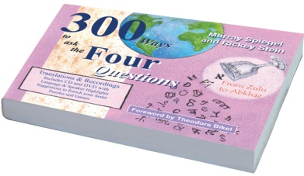

The author's acclaimed book,

*300 Ways to Ask the Four Questions*,

will be for sale at the program

(with optional personalized inscriptions)

)

**Questions? Contact Xxx Xxxxxxxx (999) 222-1234**

**email@xxxxxxxx.com for more information**

Organization

Logo

**VENUE ADDRESS**

**OTHER INFO**